Problem Statement
A municipal police analytics unit receives a raw incident table (crime type, monthly volume, severity, media attention, solved status). Command needs a ranked short-list of high-impact, non-theft cases that still require resources, plus a transparent decision rule that field supervisors and executives can both understand. The underlying skill set is basic R syntax—exactly the constructs introduced in the “Introduction to R Syntax” materials (variables, vectors, unique, sqrt/floor/ceiling, comparisons, if-else, and a dplyr select-filter-arrange pipeline).

Solution Strategy
Map every original syntax example onto a criminology task:
- Load & inspect with readr + head/summary (data-literacy check for mixed audiences).
- unique(type) → catalogue of offence categories.
- dplyr pipeline (select / filter monthly_incidents > 15 000 & type != "Theft" / arrange desc media_mentions) produces the priority list.
- sqrt / floor / ceiling convert continuous scores into discrete unit estimates.
- if-else on (high volume ∧ unsolved) yields an explicit dispatch message.
- Parameterised simulation lets the user raise/lower the threshold and immediately see the change in required officers—supporting both technical supervisors and time-pressed executives.

Solution
Running the pipeline on the supplied synthetic data (40 incidents) returns approximately 15 high-priority non-theft cases, of which ~12 remain unsolved. Top entries are typically high-media Assault, Homicide or Drug-Offense records. An if-else rule flags them for “Dispatch priority units!” Floor/ceiling of monthly volume / 5 000 supplies conservative vs optimistic patrol-unit estimates. Changing the incident threshold from 15 000 to 20 000 roughly halves the list, illustrating sensitivity for resource planning.
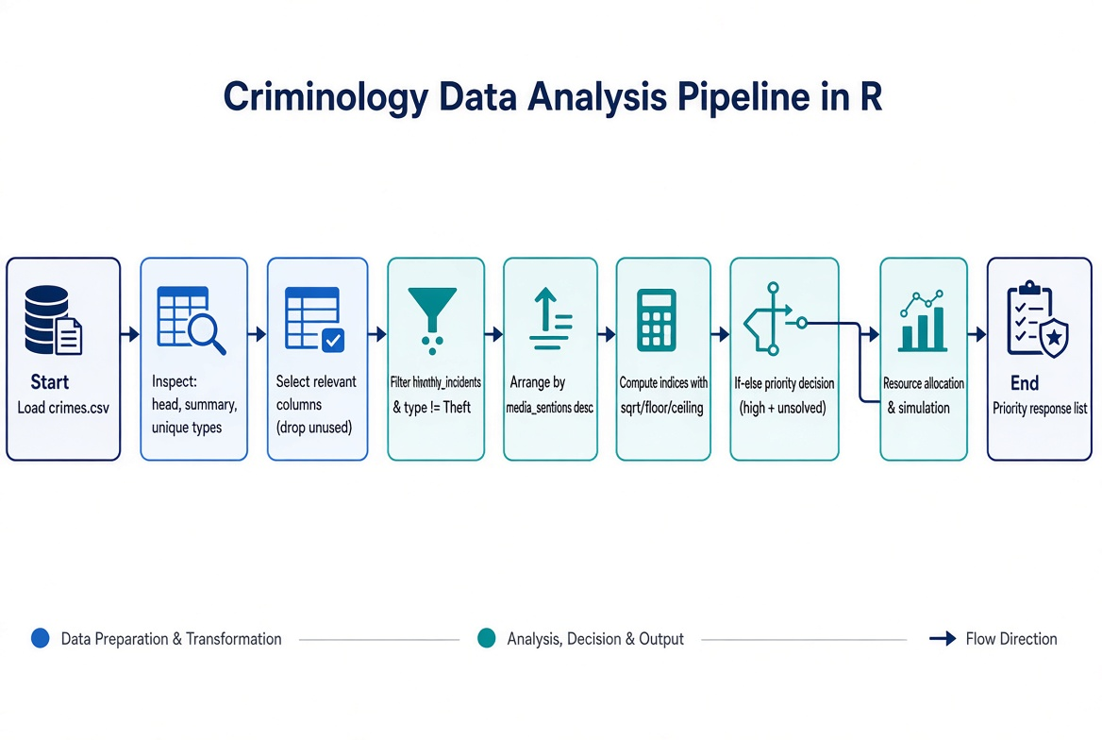
Figure: End-to-end analysis pipeline (load → inspect → filter → decide → simulate).

Key Takeaways
- All core R syntax from the introductory notebooks is sufficient to turn raw incident data into an actionable priority list.
- Audience adaptation matters: executives need the count and the decision rule; technical supervisors need the ranked IDs and the reproducible code; field users need the clear if-else message.
- A short simulation cell makes the impact of threshold changes transparent—supporting both data-literate and less data-literate stakeholders.
- Practice / Solution notebook pair + flowchart + 1-page report form a complete, self-contained extended project ready for classroom or on-boarding use.

